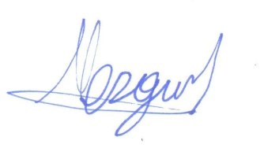
TO WHOM IT MAY CONCERN
USA Embassy in Turkey October 06, 2017
Dear Sir/Madam,
We confirm herewith that Laranazusa, is inviting:
Mr. Bulent SERBEST
to visit USA. The purpose of the visit will be to visit:

From Nov 19th to 21th, 2017
FOUR POINTS BY SHERATON SAN FRANCISCO BY BRIDGE - 1603 Powel St,

From Nov 21th to 23th, 2017
TREASURE ISLAND LAS VEGAS CASINO - 3300 S Las Vegas Blvd, Las Vegas, NV 89109

From Nov 23th to 26th, 2017
HILTON LAX HOTEL - 5711 W Century Blvd, Los Angeles, CA 90045

We confirm that LaranazUsa Inc. has booked the hotel accommodations during the stay of the client while in USA.
Please kindly assist LaranazUsa Inc. with issuing visa for the tourists mentioned above.
Director of LaranazUsa

Murat OZGUL

